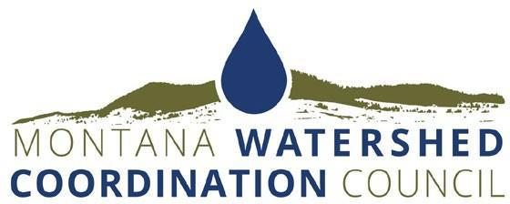

2023 Watershed Stewardship Award Nomination Form

Please submit nominations as a Word or PDF document to Terri Nichols, terri@mtwatersheds.org, by 9 am on Tuesday, February 21.

Nominator
Name and Affiliation:
Street/Mailing Address:
City, State, Zip:
Phone:
Email Address:
Nominee
Group or Individual and Affiliation
Point of Contact:
Street/Mailing Address:
City, State, Zip:
Telephone:
Email Address:
Website, if applicable:

Please limit responses to 300 words or fewer.

- Summary: Briefly summarize the nominee’s qualifying accomplishments. The summary should explain why those accomplishments are significant and why they exemplify excellence and commitment to collaborative, community-based watershed conservation, protection, restoration, and enhancement in Montana.
- Inclusive and effective local collaboration: Explain how all affected parties were or have been meaningfully involved in the process and took ownership and pride in the effort, including landowners, community members, agencies, local government, and other local partners. How does this effort align with the Watershed Approach to conservation?
- Demonstration of measurable results: Explain how activities undertaken to solve identified problems have resulted in documented improvements to watershed resources.
- Community outreach and education: Explain how effective communication and education have been important to the watershed stewardship effort.
- Holistic approach to watershed health: Explain how the effort generated or is generating a greater understanding of the integral components of the watershed, and how that understanding has led to or is leading to more holistic planning and management for watershed health.
- Supporting Documents: Attach examples of products developed for the watershed effort, i.e., photos, brochures, newsletters, news articles, work plans or strategies, maps, etc.

For more information about MWCC and local watershed efforts around the state, visit www.mtwatersheds.org

